Belhus
Cricket Club

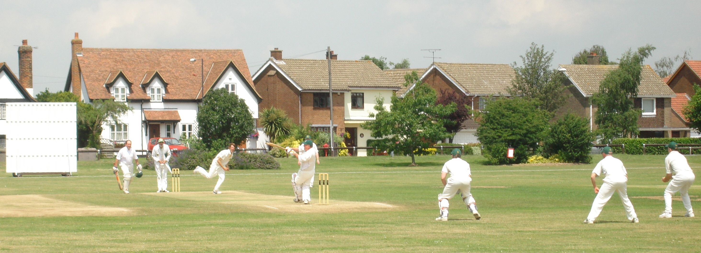

Playing Records

Batting

Records and statistics are an integral part of the game of cricket. They remind us of outstanding playing achievements and provide fond memories of team/individual performances as well as an historical record for future generations. First published in 1864, where would the game be without ‘Wisden’ ?

The records that appear on the following pages have been extracted from scorebooks in our possession and/or press reports. These batting records relate only to Senior matches (league, friendly, tour and midweek). They do not include performances in Youth matches. Unfortunately, some scorebooks have been mislaid over the years so if you have any evidential information that may add to/correct these records, perhaps you would kindly let us know. We greatly value and believe it important to record outstanding performances by our members.

Who was it who said that "a cricket club isn't a cricket club without recognising its
members' playing achievements"?.
.........………...............................................................................................................................…

Highest Innings Totals

399 for 5 1st XI v Woodford Green 13th August 2011

385 for 5 1st XI v Luton Caribbean 10th April 2021

354 for 5 2nd XI v Fives & Heronians 21st July 2018

353 for 5 1st XI v Basildon & Pitsea 26th May 2012

349 for 8 Tour XI v Norwich 25th July 2022

348 for 2 1st XI v Havering-atte-Bower 19th May 2013

346 for 6 Tour XI v Happisburgh 7th July 2010

345 all out 1st XI v Basildon & Pitsea 31st July 2011

341 for 5 1st XI v Southend-on-Sea & EMT 17th August 2013

341 for 6 2nd XI v Downshall 22nd July 1989

341 for 9 2nd XI v Old Southendian & Southchurch 13th August 2022

338 for 9 1st XI v Ongar 21st May 2011

337 for 7 1st XI v Midland Bank 27th August 1988

334 for 5 1st XI v East Essex Stallions 11th August 2013

332 for 5 1st XI v Pegasus & Corringham 27th July 2008

332 for 7 1st XI v Leigh-on-Sea 25th August 2012

328 for 5 1st XI v Upminster 7th July 2018

328 for 7 Tour XI v Norwich 7th July 2014

326 for 0 3rd XI v Old Southendian and Southchurch 13th July 2019

324 for 7 2nd XI v Norwood 24th June 1984

323 for 6 1st XI v Horndon-on-the-Hill 14th May 2017

320 for 6 2nd XI v Sidcup 10th September 2005

320 all out 1st XI v Stork 10th August 1986

319 for 0 Sunday XI v Brentwood Victorians 30th May 2021

318 for 1 1st XI v Billericay 3rd July 2010

314 for 8 2nd XI v Hainault & Clayhall 23rd July 2016

310 for 5 5th XI v Hornchurch 28th May 2022

309 for 2 1st XI v Waltham 14th September 2014

309 for 3 2nd XI v Horton Kirby 3rd August 2014

308 for 8 1st XI v Barking 22nd July 2006

308 for 7 Tour XI v Norwich 13th July 2015

306 for 3 1st XI v Stanford-le-Hope 8th September 2012

306 for 4 2nd XI v Epping 6th July 2013

306 for 6 1st XI v May & Baker 4th August 2007

305 for 2 1st XI v Rainham 8th August 1998

305 for 7 1st XI v Noak Hill 23rd August 2003

305 for 1 1st XI v Benfleet 20th May 2012
303 for 5 1st XI v Benfleet 30th May 2010
303 for 5 2nd XI v Old Parkonians 10th July 2010
303 for 9 1st XI v Upminster 21st June 2015
302 for 7 2nd XI v Gidea Park & Romford 6th August 2016
301 for 3 Midweek XI v Old Victorians 24th August 2016
301 for 5 5th XI v Harold Wood 23rd July 2022
301 for 7 1st XI v Benfleet 4th June 2011
301 for 9 Tour XI v Overstrand 26th July 2022
300 for 3 2nd XI v Little Thurrock 8th July 1989

Highest Opposition Totals

406 for 6 Barking v 3rd XI 3rd June 2006

398 all out Eton Manor v 2nd XI 9th August 2003

376 for 2 Offham v 1st XI 23rd May 2004

348 for 7 East Ham Manor v 1st XI 26th August 1990

348 for 9 Dover (Barbados) v Tour XI 21st October 1991

342 for 6 Colchester & East Essex v 2nd XI 6th July 2019

342 for 8 Southend-on-Sea & EMT v 1st XI 17th August 2013

341 for 8 South Woodford v 1st XI 25th April 2009

335 for 6 Wickford v 2nd XI 3rd September 2006

326 for 2 Horndon-on-the-Hill v 1st XI 14th May 2017

325 all out Norwich v Tour XI 7th July 2014

323 for 3 Harold Wood v 5th XI 23rd July 2022

322 for 8 Fords v 2nd XI 11th August 2007

319 for 6 Cassowaries v 3rd XI 20th April 2013

317 for 1 Brentwood Victorians v Sunday XI 30th May 2021

317 for 8 Ongar v 1st XI 17th July 2010

316 for 7 Barking v 1st XI 22nd July 2006

314 for 3 Southend-on-Sea v 1st XI 8th May 2005

313 for 4 Hainault & Clayhall v 2nd XI 23rd July 2016

312 for 7 Norwich v Tour XI 4th July 2011

312 for 7 Leigh-on-Sea v 1st XI 31st August 2013
311 for 2 Clacton v 1st XI 23rd May 1998

311 for 7 Goresbrook v 2nd XI 5th July 2009

310 for 6 Eton Manor v 1st XI 27th July 1974

306 for 5 Bairds v 4th XI 31st May 2008

305 for 6 Noak Hill v 1st XI 20th August 2005

304 for 9 Fords v 1st XI 4th May 1996

302 all out Noak Hill Taverners v 2nd XI 3rd June 2006

300 for 5 Norwich v Tour XI 7th July 2008

Most fifties in a Belhus Innings

5 M. Chowdhury 101 1st XI v
G Philpot 56 Luton Caribbean
J Joyce 52 10th April 2021
M Osborne 52
S Barwick 50
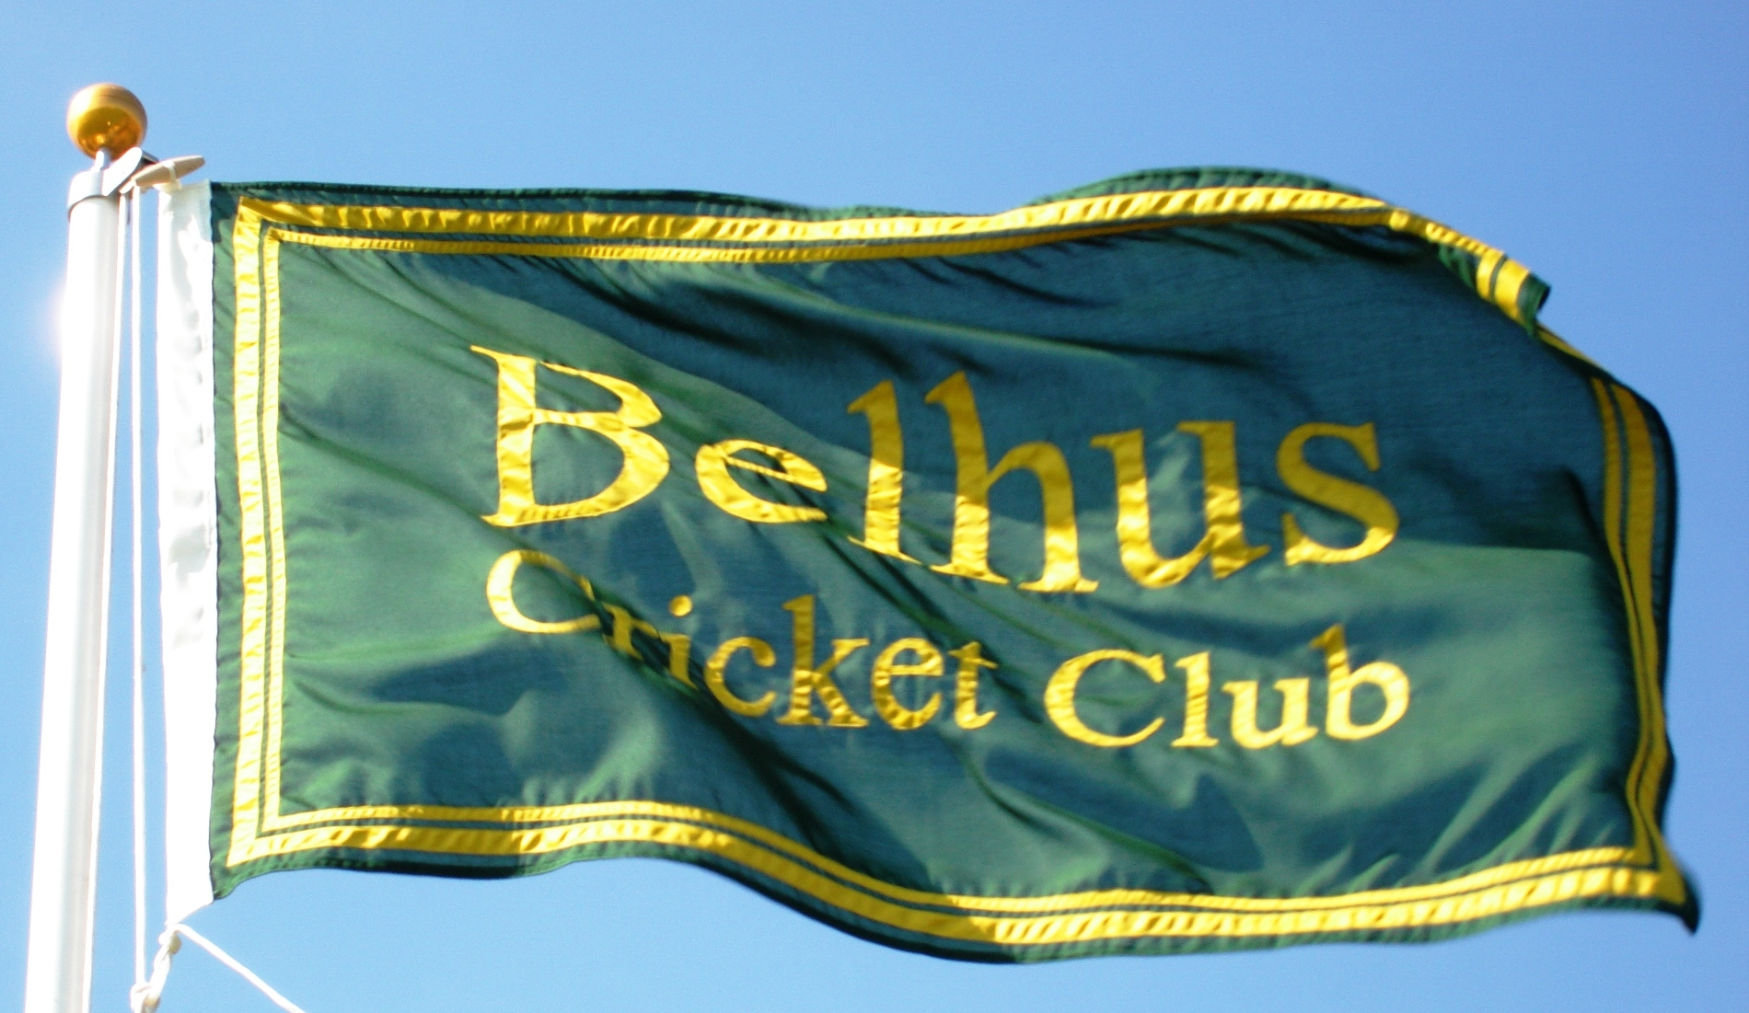

Lowest Innings Totals

5 4th XI v Bexley 28th July 2007

14 2nd XI v Great Burstead 7th August 1960

14 1st XI v Tennyson 2nd May 1965

15 4th XI v Orpington 12th May 2007

16 4th XI v Chevening Amblers 2nd June 2007

17 1st XI v Greenleaf 24th May 1975

20 2nd XI v Corringham Social 3rd July 1966

20 2nd XI v Roydon 13th August 1966

21 2nd XI v Woolwich Telephones 16th August 1975

22 2nd XI v Essex United 25th May 1980

22 2nd XI v North Ockendon 12th May 1962

23 2nd XI v Harold Hill 28th August 1966

23 1st XI v Leyton Great Eastern 3rd September 1967

24 2nd XI v Fords 8th May 1960

24 2nd XI v Dagenham 26th May 1973

Lowest Opposition Totals

14 Pinchin Johnson Associates v 1st XI 1st May 1966

19 Midland Bank v 2nd XI 16th May 1981

21 South Ockendon Hospital v 2nd XI 22nd September 1960

21 Southend Hospitals v 1st XI 29th April 1979

21 Old Southendian & Southchurch v 3rd XI 11th May 2019

22 Green Lodge v 2nd XI 23rd June 1962

22 Procter & Gamble v 1st XI 20th May 1982

23 Aveley v 1st XI 13th August 1960

24 Kennedy v 1st XI 2nd May 1964

25 South Ockendon Hospital v 1st XI 30th April 1960

Highest Total Batting First

399 for 5 1st XI v Woodford Green 13th August 2011

Highest Total Batting Second

319 for 0 Sunday XI v Brentwood Victorians 30th May 2021

Highest Winning Total Batting First

399 for 5 1st XI v Woodford Green 13th August 2011

Highest Winning Total Batting Second

319 for 0 Sunday XI v Brentwood Victorians 30th May 2021

Highest Losing Total Batting First

341 for 5 1st XI v Southend-on-Sea & EMT 17th August 2013

Highest Aggregate Runs in a Match

685 1st XI 399 for 5 Woodford Green 286 13th August 2011

683 1st XI 341 for 5 Southend-on-Seas & EMT 342 for 8 17th August 2013

Highest Losing Total Batting Second

274 for 9 1st XI v Leigh-on-Sea 5th July 2014

Largest Victory by Ten Wickets

319 for 0 Sunday XI v Brentwood Victorians 30th May 2021
(Ryan Wells 204*, Henry Overy 75*)

Largest Victory Margin by Runs

301 1st XI 385 for 5
v Luton Caribbean 84 10th April 2021

Highest Individual Scores

204* Ryan Wells Sunday XI v Brentwood Victorians 30th May 2021

200* Paul Bennett 1st XI v Havering-atte-Bower 19th May 2013

181* Wayne Read 3rd XI v Rainham ew 4th August 1984

178 Wayne Read Midweek XI v Goresbrook 19th July 1990

177* Max Osborne 1st XI v Upminster 7th July 2018

175* Paul Bennett 1st XI v Benfleet 30th May 2010

174* Robert Healy 5th XI v Hornchurch 28th May 2022

173* Aaron Tan 2nd XI v Eton Manor 23rd June 2001

172* Danny Joyce 1st XI v Woodford Green 13th August 2011

171 Joe Joyce 1st XI v Horndon-on-the Hill 20th June 2015

163* Michael Cansdale 3rd XI v Old Southendian and Southchurch 13th July 2019

162* Joe Joyce 1st XI v Waltham 14th September 2014

161* George Maidment 4th XI v Southend-on-Sea & EMT 30th June 2018

161* Wayne Read 2nd XI v Old Southendian & Southchurch 13th August 2022

161 Bradlee Sharpe 3rd XI v Hawks 17th July 2004

159 Richard Waters 2nd XI v Little Thurrock 8th July 1989

158 Wayne Read 1st XI v Harold Wood 6th September 1997

158 Wayne Read 1st XI v Basildon & Pitsea 27th September 1997

157 Ryan Wells 1st XI v East Essex Stallions 11th August 2013

155* Dave Aldridge 1st XI v Rainham 8th August 1998

155* Henry Overy 2nd XI v Frenford 16th July 2023

154 Joe Joyce 1st XI v Old Southendian & Southchurch 17th August 2013

153* Terry Lambert Jnr 1st XI v Fords 12th July 1997

151* Ryan Wells 2nd XI v Orsett 1st September 2012

151 Wayne Read 1st XI v Midland Bank 27th August 1988

150* Greg Mendham 4th XI v Billericay 7th September 2013

150* John Lewis Jnr 2nd XI v Ardleigh Green 28th June 2014

Fastest Century

51 balls Dan Dreher 2nd XI v West Essex 10th June 2017

Fastest Fifty

13 balls Ryan Wells Tour XI v Norwich 29th July 2019

Highest Individual Scores for Each XI

1st XI 200* Paul Bennett v Havering-atte-Bower 19th May 2013

2nd XI 173* Aaron Tan v Eton Manor 23rd June 2001

3rd XI 181* Wayne Read v Rainham 27th August 1984

4th XI 161* George Maidment v Billericay 30th June 2018

5th XI 174* Robert Healy v Hornchurch 28th May 2022

Midweek XI 178 Wayne Read v Goresbrook 19th July 1990

Record Wicket Partnerships

1st 326* Michael Cansdale (163*) and Tom Thompson (145*)
3rd XI v Old Southendian and Southchurch 13th July 2019

2nd 242 Joe Joyce (117*) and Danny Joyce(112)
1st XI v Bentley 4th June 2023

3rd 238 Paul Wiltshire (62*) and Richard Waters (159)
2nd XI v Little Thurrock 8th July 1989

4th 260 Danny Joyce (99) and Max Osborne (177*)
1st XI v Upminster 7th July 2018

5th 171 Mathew Lewis Snr (70*) and Danny Norris (110)
2nd XI v Leigh-on-Sea 7th July 2012

6th 173 Nick Marns (124) and Steve Huckstepp (36)
Tour XI v Norwich 3rd July 2006

7th 145* Steve Huckstepp (56*) and John Forrest (82*)
1st XI v Pegasus 26th June 1988

8th 151 Gavin Jefferies (50*) and Paul Whitlock (101)
2nd XI v Mountnessing 3rd June 2007

9th 162* Francis Baptiste (70*) and Richard Dopson (84*)
2nd XI v Havering-atte-Bower 4th September 1999

10th 155* Roy Heffernan (135*) and Sam Hall (23*)
1st XI v Myddleton House 30th June 2013

Most Runs in a Season

2,111 Joe Joyce
39 innings, 8 not out, Average 68.10 2017

Most Runs in an Over

40 Ryan Wells
Tour XI v Norwich 29th July 2019

Most Sixes in an Innings

14 Wayne Read
1st XI v Midland Bank 27th August 1988

Most Sixes in an Over

6 Ryan Wells
Tour XI v Norwich 29th July 2019

Most Fours in an Over

6 Scott Bayford
1st XI v Broomfield 30th May 1999

Most Centuries in a Season

9 Joe Joyce 2014

Highest Score at Each Batting Position

No. 1 204* Ryan Wells
Sunday XI v Brentwood Victorians 30th May 2021

No. 2 200* Paul Bennett
1st XI v Havering-atte-Bower 19th May 2013

No. 3 181* Wayne Read
3rd XI v Rainham 4th August 1984

No. 4 178 Wayne Read
1st XI v Goresbrook 19th July 1990

No. 5 177* Max Osborne
1st XI v Upminster 7th July 2018

No. 6 125* Scott Bayford
Tour XI v Happisburgh 7th July 2010

No. 7 105* Joe Joyce
1st XI v Gidea Park & Romford 28th May 2017

No. 8 123 Scott Bayford
2nd XI v Kingfisher 27th April 2003

No. 9 135* Roy Heffernan
1st XI v Myddleton House 30th June 2013

No. 10 84 Richard Dopson
2nd XI v Havering-atte-Bower 4th September 1999

No. 11 71 Billy Maidment
2nd XI v Crusaders 9th August 2015

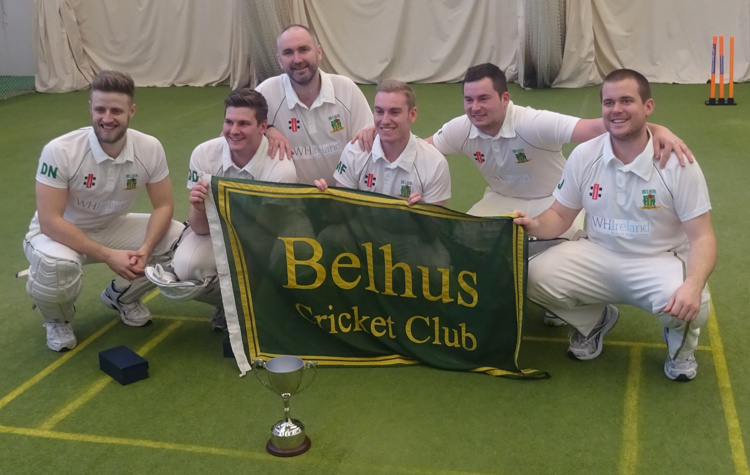
National Indoor Champions 2016

